<https://www.techblog.vn/mediarecorder-and-camera-in-android>

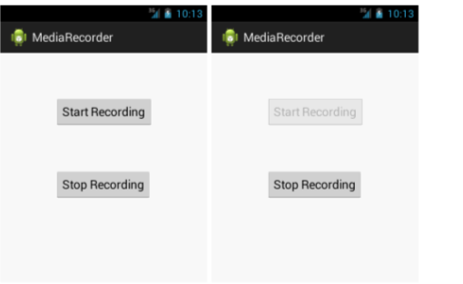

<https://www.javatpoint.com/android-mediarecorder-example>

<https://code.tutsplus.com/vi/tutorials/how-to-make-calls-and-use-sms-in-android-apps--cms-28168>

<https://duythanhcse.wordpress.com/2013/05/04/bai-tap-26-dung-implicit-intent-de-viet-chuong-trinh-goi-dien-thoai-va-nhan-tin-sms/>

String dial = "tel:" + phoneNo;

startActivity(new Intent(Intent.ACTION_DIAL, Uri.parse(dial)));